Gaia-Gov
About This App
Welcome to Gaia-Gov This app is a bottom-up platform where account holders like you are the core influencers. It empowers citizens by providing clear, unbiased information about laws made by political leaders, giving ordinary people the ability to act, rather than comment or voice an opinion. Gaia-Gov brings ordinary people closer to their governments.
Purpose of Gaia Gov
Gaia Gov does not engage in elections or political campaigns. Instead, it helps you understand and influence the actual laws created by governments. By offering a transparent, interactive environment, it enables citizens to participate in legislative processes by moving their support between lawmakers inside a legislative body 24/7 365 days a year.through
Objectives
Make law-making transparent and inclusive
Offer non-political education about how laws affect daily life
Promote open debate and citizen involvement in governance.
Key Services
Personalized Lawmaker Mapping Based on your location, see which lawmakers are using your influence across government levels.
Green Dot Algorithm Virtually assign your influence to a lawmaker who aligns best with your values.
Info Access Tap on any lawmaker’s picture to view their actions and justifications.
Consensus Reporting Submit your actions, not your opinion to influence government consensus metrics.
Live Debates Watch and participate in live open debates at multiple levels of government every Wednesday.
Your Role as an Account Holder
By joining Gaia Gov, you take responsibility in:
Understanding and answering the three questions about how good laws are created. 1.Minimizing interference, 2. Minimizing oppression by eliminating privilege, 3. Maintaining democratic legitimacy.
Feature list for Gaia-Gov
Account holder module
1.-Download Gaia-Gov from App Store or Play Store.
2 -Splash Screen followed by an open page with control panel the first tab is [Information]. The information tab when opened consists of a mission statement from Gaia-Gov, and an explanation of how the software works, how the cascade of events is used to involve legislative bodies the account holder may know and the benefits of bringing the resource of many people’s intellect together to make the best laws.
A tab [Would you like to be an account holder?]
Space to add tabs in future like “would you like to watch an open and free debate outside of your territorial boundary?” and features to be added later to improve the services Gaia-Gov offers. The splash screen is done, The first page needs to be done with a tab directing account holders to explain the importance of enhancing our present law making mechanisms.
3 -request to set up an account. [Yes]
-Software to create a secure account with password and credentials.
4 -Software to vet and set up files on account holders. The account holder file should be keyed after vetting for confidentiality.
5.-Perhaps allow uploading a photo of a driver's licence or other official document to authenticate the ID of the account holder. This will be available to the resource persons in the legislative office. After vetting, the account holder's GPS location and data transfer into files used to calculate POC and place photos of lawmakers onto the home screen should be keyed.
6 -GPS location of home address. To be used to locate account holders on the base map. [Use location of device] [Manually enter]
7 -Create a home page. When the home page is opened, the account holder sees a picture of which lawmaker is using their support to make law within the territorial boundaries of any legislative body that has been developed at their GPS location.
The row will consist of three modules: the Account Holder module, the Gov module and the Open and Free Debate module. The picture of the lawmaker or if lawmaker hasn’t uploaded picture a blank with lawmaker’s name under is on the first module, the account holder module, The second module will be populated with the logo of the legislative body and the third will be named “Open and Free debate” this front end for the home page has been developed.
8 - create a tab to add an empty layer of authority to be developed by the account holder. This first new module will initially be labeled [To develop please select]. The account holder must tap the button, fill in the email of legislative body or lawmaker and push the [submit] button at bottom of page to begin a cascade of events, that is; The legislative body must accept the invitation, upload the software using the URL on invitation, assign Gaia-Gov to a resource person who fills in a list of emails and names of the lawmakers, including the lawmaker elected in the electoral district of the account holder. The lawmaker must accept the invitation and upload their photo. This photo will appear on the account holders home page.
9 -Create a second page that is opened when the account holder touches the picture of the lawmaker on the home screen.
10 - The second page consists of a list of all lawmakers in the legislative body represented by their photo on the left, their credentials, a graph of support over time next to the photo and next to that a blog spot that can be expanded by tapping on it.
11 -on the far left is an empty circle that is green if that is the lawmaker who was elected in the electoral district the account holder lives in. The account holder can select a different lawmaker from the list of lawmakers in the legislative body by selecting the empty circle to the left of the lawmaker that better represents their interests. The system asks, do you want to move your support from the lawmaker who is using their support to the lawmaker they prefer? Yes or NO. If they select [Yes] then the green dot moves to the new lawmaker, the new lawmaker’s graph goes up one and the old lawmaker’s graph goes down by one and the new lawmaker’s photo is seen on the home page of the account holder. To the right of the green dot is the photo of the lawmaker. When touched a new screen with the name, official credentials, responsibilities and position in the party of the selected lawmaker and a back key to return to the second page. To the right of the law maker’s photo is a graph of gain or loss using a logarithmic scale reflecting large or small gains or losses. To the right of the graph is a blog spot, that when touched is a written message from the lawmaker. Most of this is in the software that has been developed to date.
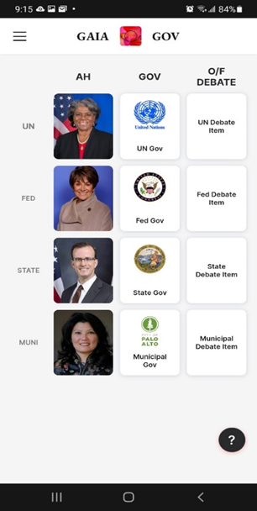Home page if your GPS location was Palo Alto California and 4 layers of authority have been developed.
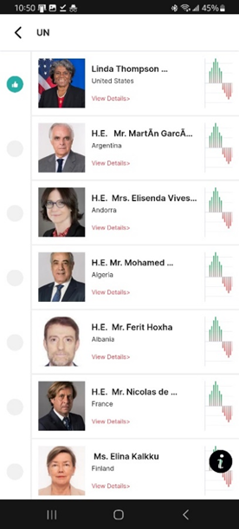
Second page if the UN level was selected.
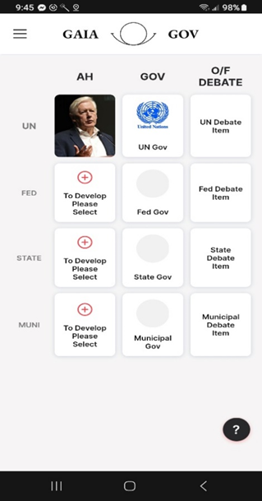
Each layer is developed from one complete block of software. In the example there are three undeveloped layers. There should only be one. An account holder can add a layer and enter an email of the legislative body after they select [To develop please select]. This initiates a cascade of events starting with the legislative body agreeing to become part of Gaia-Gov, downloading Gov module software, assigning a resource person the task of uploading a territorial map and entering a list of lawmakers. Gaia-Gov automatically sends an invite to the law makers in the list, the lawmaker accepts the invitation, uploads a picture of themselves and sets up their blog spot.

12 -Create a system that records and saves a snapshot of support at time intervals, like every hour. This information will be used to calculate the POC (percentage of consensus) of each piece of legislation (law) at the time the bill is passed into law.
13 -Create a backend algorithm to take the sum of support of lawmakers voting yes at the time a bill is passed into law divided by the number of voters in the election or the number of account holders inside the territorial map of the legislative body times one hundred to arrive at the percentage of consensus (POC) for the law. The POC is posted beside the legislation in the Gov module.
Gov module
14 -Create a base map, (world map)
15 -build Gov Module software. This is the software the legislative body uploads after they accept the Gaia-Gov invitation, assign a resource person to the task, and that person selects the URL on the invitation to upload the Gov module. This software is only seen by members of the legislative body.
16 -Software to create a secure account with password and credentials to set up gov software.
17 - The software consists of a territorial map as the background of the control panel with the GPS location of the legislative office as the only mark on the map. Tabs labeled [Upload Territorial Map], [Upload Legislative List of Lawmakers], [Upload results of Open and Free Debates], [Upload Legislative Agenda], [Laws passed with POC] (percentage of consensus of previous legislations), [Notices of events and meetings] and any other function that can improve the services Gaia-Gov provides.
18 -Create software to allow resource persons to upload the territorial map of the legislative body. After the map has been uploaded the resource person will see their territory clearly shaded on the base map which is the background of their control panel. Gaia-Gov could upload official government maps, but it would be better if the legislative body in question takes on this responsibility.
19 -Create software allowing lawmakers to upload their photo and to set up their blog spot. This software will be available to the lawmakers after they accept the invitation that will be automatically sent to them by Gaia-Gov using the email entered by the resource person into the legislative list.
-Software to create a secure account with password and credentials to set up a lawmaker's account.
-Create control panel with territorial map as background with following tabs. [Upload photo]and [Blog spot]. When first opened, the lawmaker will need to set up an account, set up their blog spot, but later they just open it and edit what is there or add new content.
- This software is only seen by the lawmaker.
20 -Create software used by the resource person to promote advertising in the Open and Free Debate module. This consists of software showing available advertising slots that can be emailed to business licence holders within the territorial boundaries of the legislative body. It will be the responsibility of the legislative body to approve of the advertisements before they are aired in the live Open and Free Debate secession.
21 -The front end seen by the account holder after they tap the Gov module will consist of what the legislative body has entered into public categories like Announcements, results of Open and Free Debates and information of future debates, legislative agendas and so forth.

Open and Free Debate module
22 -Create a control panel consisting of tabs over a background of the territorial map of the legislative body.
23 -First tab: [Information] An explanation of the purpose. That is; identify issues inside the territorial boundary of the legislative body and to create the best framework law to address the identified issue. The account holder must participate by identifying issues or selecting the most important issue to them that has already been identified, by selecting or being one of the nine best debate teams they think can produce the best framework law and being or selecting the best moderator.
Second tab: [Issues] when opened gives account holders the ability to either submit new issues or support established issues. The most popular issue is posted just after the last debate with the next debate scheduled 4 weeks hence.
Third tab: [Debate teams] When an issue is posted account holders can form teams and post them here. If they don’t want to be debaters, they can select up to 9 debate teams. At the three week mark Gaia-Gov selects the most popular teams and posts them.
Fourth tab: [Moderator] The account holder must post themselves as moderator or support the moderator they think will do the best job
24 -Create an automatic debate schedule; that is every Wednesday between 4 PM and 8 PM starting with the moderator’s introduction of teams and then automatic 5-minute time slots,broken up with 15 second advertising slots.
https://drive.google.com/open?id=1oblTTE4C4PZMYc8_CPv3ePsmzq_uh61w&usp=drive
Open and free debate schedule .xlsx

Gaia-Gov Administrative Software

25 -Create billing software allowing advertising customers to pay electronically with credit card or whatever for advertising space on the open and free debate.
26 -Create software to adjust advertising prices using a competitive algorithm.
27 -Create software to automatically pay the legislative body 90% of advertising revenue or amount that works to sustain and have a reasonable profit for Gaia-Gov.

https://www.figma.com/file/j5cNnJ4k4RnxxH8nynm09V/GAIA-Gov?fuid=1524117484389541639
.

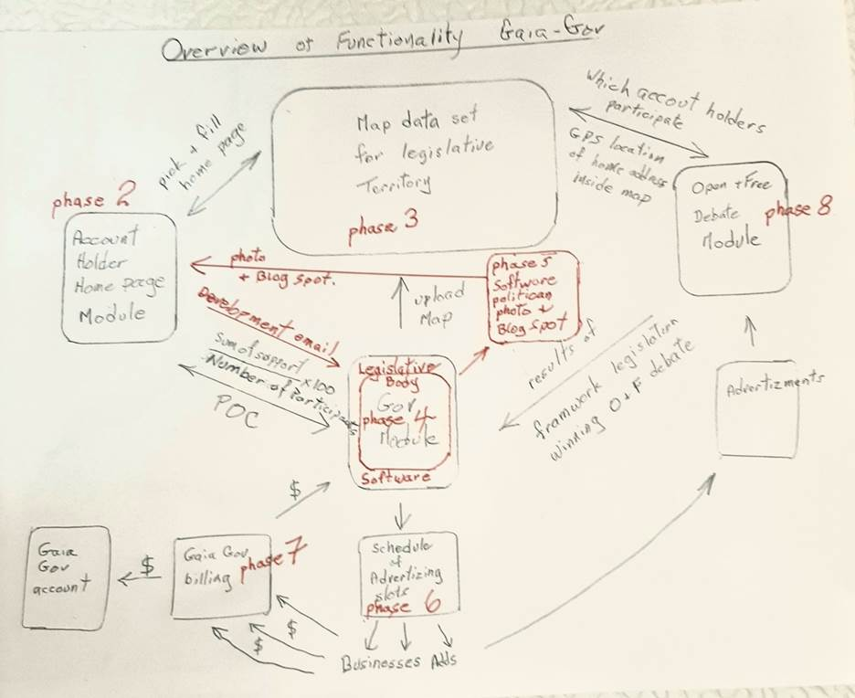

Backend
28. Build a world base map to hold territorial maps of legislative bodies.
29. Build a database for each account holder with key, GPS location, legislative district, lawmaker preference and information needed to populate the home page of individual account holders.

30. Build a database for lawmakers with photo and blog spots.

31. Build a database for Gov module with list of lawmakers, map data of territorial map, software to collect data of support, build system to save data snapshot of support and store every hour. Build the algorithm to calculate the POC for each legislation created by the legislative body.

32. Build software to qualify participation using the GPS location of account holders inside the territorial map of the legislative body.

33. Build a database to compile support for participating debate teams by account holders in open and free debate sessions.
.
34.Build automatic 4 hour open and free debate time table.

35. Compile data.

